Linux Fundamentals Part 1
DG Interns Hub | Week 1 | TryHackMe Room Writeup

Objective
Learn basic Linux terminal navigation and file operations.

Activity summary
Reviewed shell navigation and introductory commands in the guided exercises.

Key learning
pwd, ls, cd, cat and file-system navigation.

Evidence
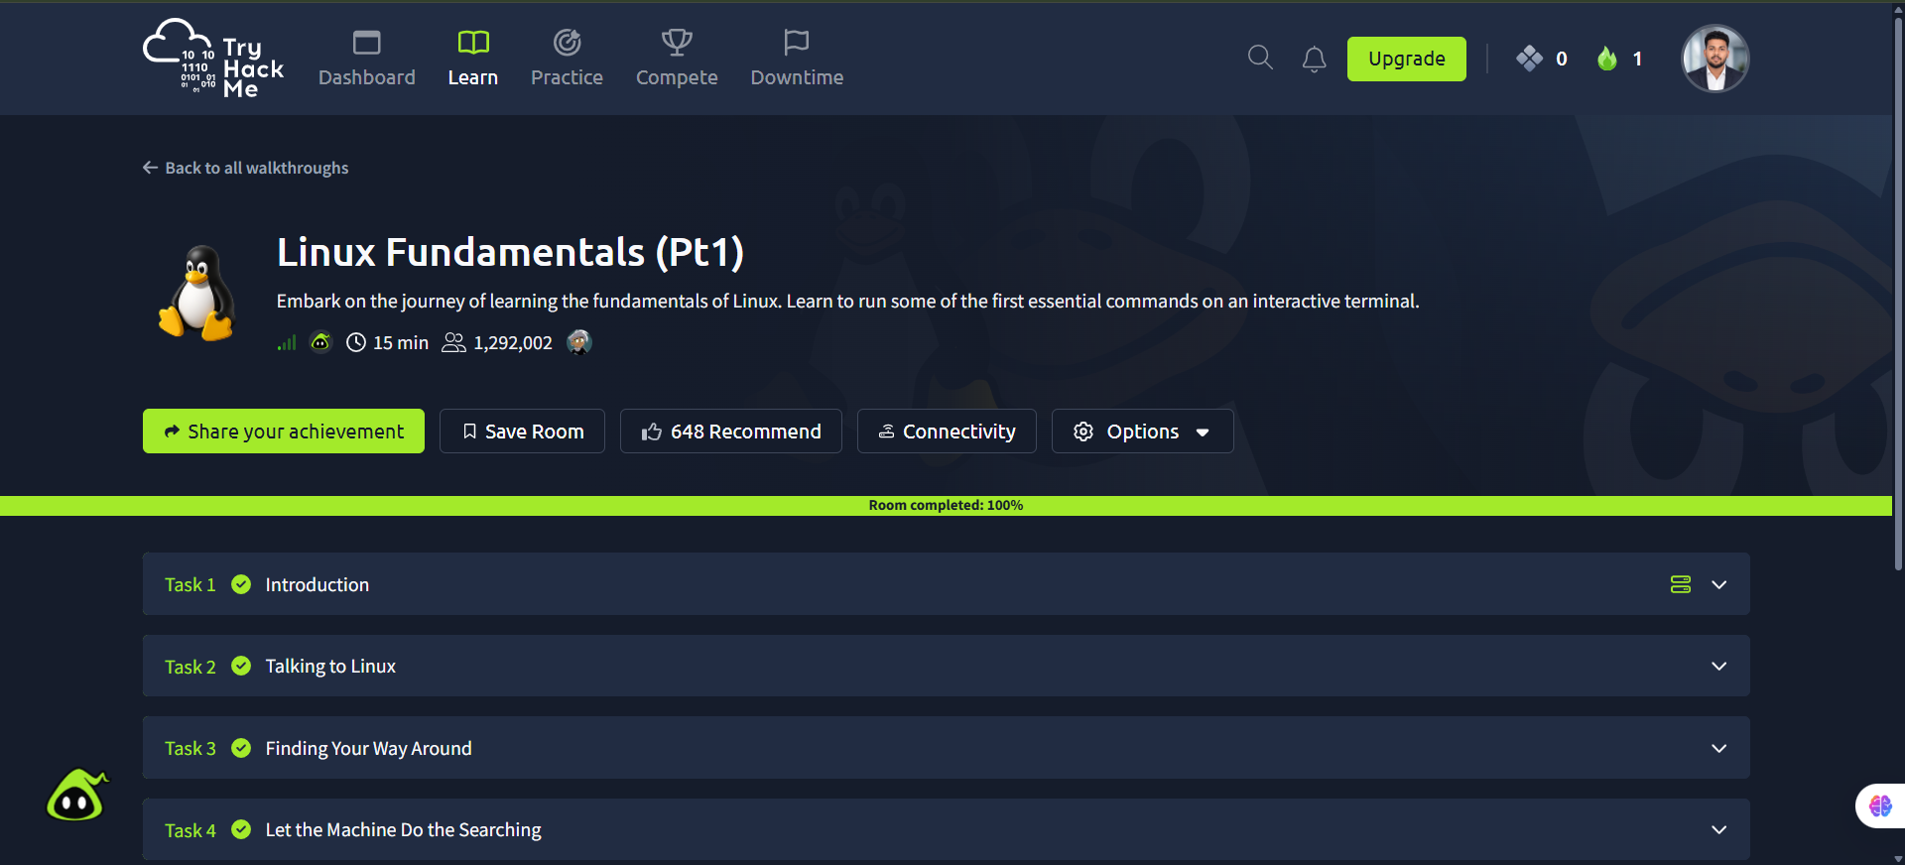
Screenshot: Linux_Fundamentals_Part1.png
Completion screenshot provided; the original step-by-step room answers were not included in the archive.

